YOUR UPCOMING ESOPHAGOGASTRODUODENOSCOPY (EGD) IS SCHEDULED:

_________________________check in at______________________

Dr. Evans Dr. Srinivasan Dr. Tiwari

Please call 541-222-6200 with any questions.

TIMETABLE
7-14 days prior | 5 days prior | Day Prior | Day of
Arrange for a ride/escort  Hold all GLP-1 medications (See page 3 for examples) | Hold all Iron Supplements | After midnight, no solid foods | Can take meds up to 2 hrs prior. Clear liquids only. (Continue to take Beta Blockers as directed.  See page 2 for a full list)
Confirmation call |  |  | Stop everything by mouth including all liquids, smoking and gum/mints 2 hours prior to check in
 |  |  | Hold Metformin

CONFIRMATION
Please notify staff during appointment confirmation prior to your procedure if you have a history of cardiac stents, organ transplant, fluid in the abdomen, heart grafts, any blood disorders or are taking blood thinners.
Our office MUST make contact with you to confirm, or your procedure will be canceled. If you do not receive a call from our staff a week prior to your procedure or have questions, please call 541-222-6200.

CANCELING/RESCHEDULING PROCEDURE
If you want to cancel or reschedule your appointment, please call 541.222.6200 at least 7 days prior to your scheduled appointment. This helps us to schedule the next patient waiting to be seen.
TRANSPORTATION

You must arrange for an adult family member or friend to drive you to your procedure and home from your procedure. They will need to be available throughout your appointment. It is the policy of PeaceHealth that you have a responsible adult accompany you home after your procedure (a bus or taxi ride is not an option) In the event you are unable to arrange for a driver to accompany you to and from our endoscopy unit, your procedure will need to be rescheduled.
SEDATION

Sedation medication helps you relax and feel comfortable during the procedure. You may feel fine after your procedure, but your judgement will be impaired from the sedation medication you receive. *Do not drive, make legal decisions, return to work, or drink alcohol for the remainder of the day.

PATIENTS ON BLOOD THINNING MEDICATIONS
If you take any medications to thin the blood such as Coumadin, Warfarin/Jantoven, Plavix, Brilinta, Eliquis, Pradaxa, Effient, Jantovan, Pletal, or Xarelto, you will need specific instructions when to stop these medications. Most patients will need to stop these medication 2-5 days prior to your procedure.
A staff member will be calling to confirm your appointment and will go over your special instructions such as how long to hold your blood thinner.
**Coumadin/Warfarin/Jantoven patients will have Protime/INR checked after checking in for their procedure. The INR needs to be below 1.5 on the day of procedure.
HYPERTENSION PATIENTS
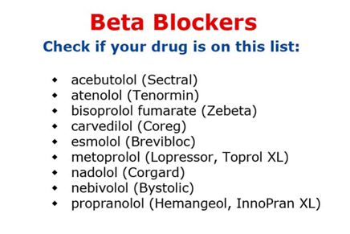
A staff member will be calling to go over your blood pressure medications with you prior to your procedure. If you take Losartan and/or Lisinopril, hold that medication the day of the procedure.

DIABETIC PATIENTS
- If you take a GLP-1 “tide” injectable diabetic medication (Trulicity, Byvetta, Victoza) DO NOT take for 1 week prior to your procedure.
- If you take a “gliflozin” diabetes pill (Farxiga, Invokana, Jardiance), DO NOT take for 3 days prior to your procedure.
- DO NOT take any oral or injectable diabetic medications on the morning of your procedure.
- If you have a manual insulin pump, keep it on nighttime basal the morning of your procedure. Automatic pumps can be left on sensing mode.

GLP-1 Medications
Hold for seven (7) days prior to procedure.

Name | Brand
Exenatide | Byetta
Exenatide | Bydureon
Liraglutide | Victoza
Albiglutide | Tanzeum
Dulaglutide | Trulicity
Lixisenatide | Lixumia
Beinaglutide
Semaglutide | Ozempic
Semaglutide | Rybelsus
PEG-loxenatide | Fu Laimei
Tirzepatide | Mounjaro

If you have any questions, please reach out to the clinic @ 541-222-6200

PeaceHealth Medical Center
Endoscopy
RIVERBEND PAVILION
3377 Riverbend Drive – 2nd FLOOR
Springfield, Oregon 97477
541-222-6200
Parking Garage "C” is attached to the Pavilion building
(A map is on the back of this page with the Pavilion and Parking Garage C circled)
The Pavilion Building DOES NOT have a Blue Roof awning
Entrance into The Pavilion from the parking garage is
ONLY on the GROUND or 3rd FLOOR
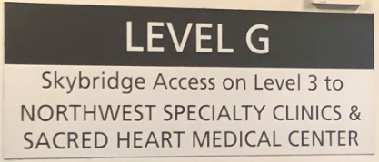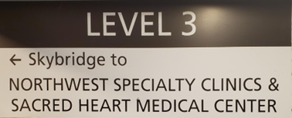
ENTER PAVILION THROUGH GREEN DOORS

DO NOT USE BLUE DOORS
DO NOT TAKE SKYBRIDGE

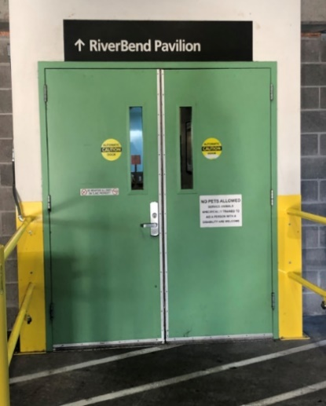
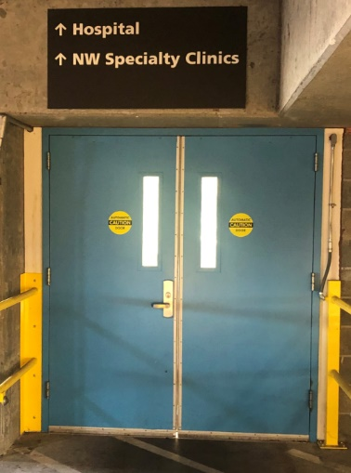

When inside the Pavilion building, take the elevator or stairs to the 2nd floor.
Once out of the elevator, take a hard left turn for Endoscopy procedure desk.

